Silent Auction: One Week Stay at the O’asis in Ribera, Baja California– A $700 Value!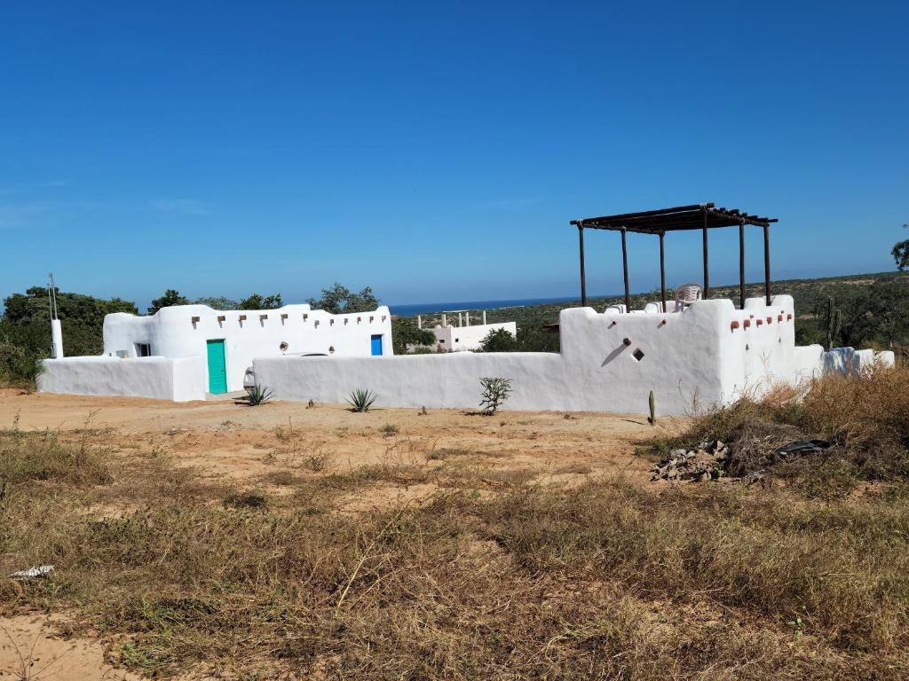
This property is a 18-minute walk from the beach. Facing the beachfront in La Ribera, The O'asis features a bar and a garden. Featuring a shared kitchen, this property also provides guests with a grill.
At the guesthouse, all rooms come with a closet. Complete with a private bathroom, all guest rooms at The O'asis are equipped with air conditioning, and some rooms come with a seating area. At the accommodation all rooms are equipped with bed linen and towels.
The O'asis has a terrace. Guests at the guesthouse will be able to enjoy activities in and around La Ribera, like hiking and cycling.
The nearest airport is Los Cabos International Airport, 31 miles from The O’asis. For more information and photos visit: http://www.booking.com/Share-Z1hWZJ

