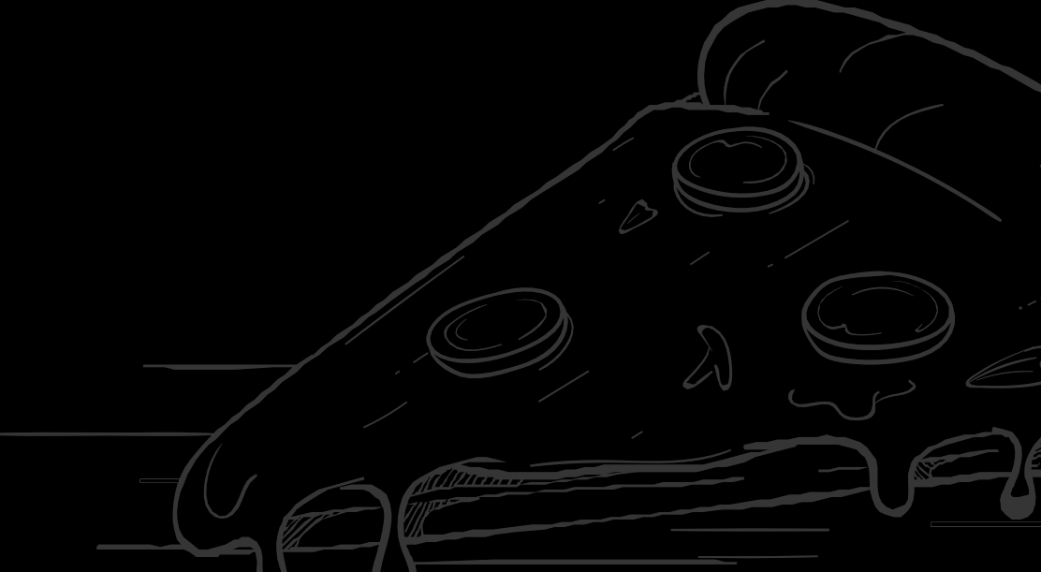

Treat yourself, family, and friends to
dinner at the
Oakhurst, Mariposa or North Fork Pizza Factory locations
March 19 & 20 from 4:00pm to Close.

THE Rotary District 5220, Area 9 Clubs:
Oakhurst Sierra, Oakhurst Sunrise and Mariposa Yosemite
have partnered with our Pizza Factory location

A portion of your purchase
will be donated to the local clubs to support the Rotary Foundation for local and global disaster relief efforts.

